**Exp No:4 Stock Maintenance System**

Use Case Diagram:

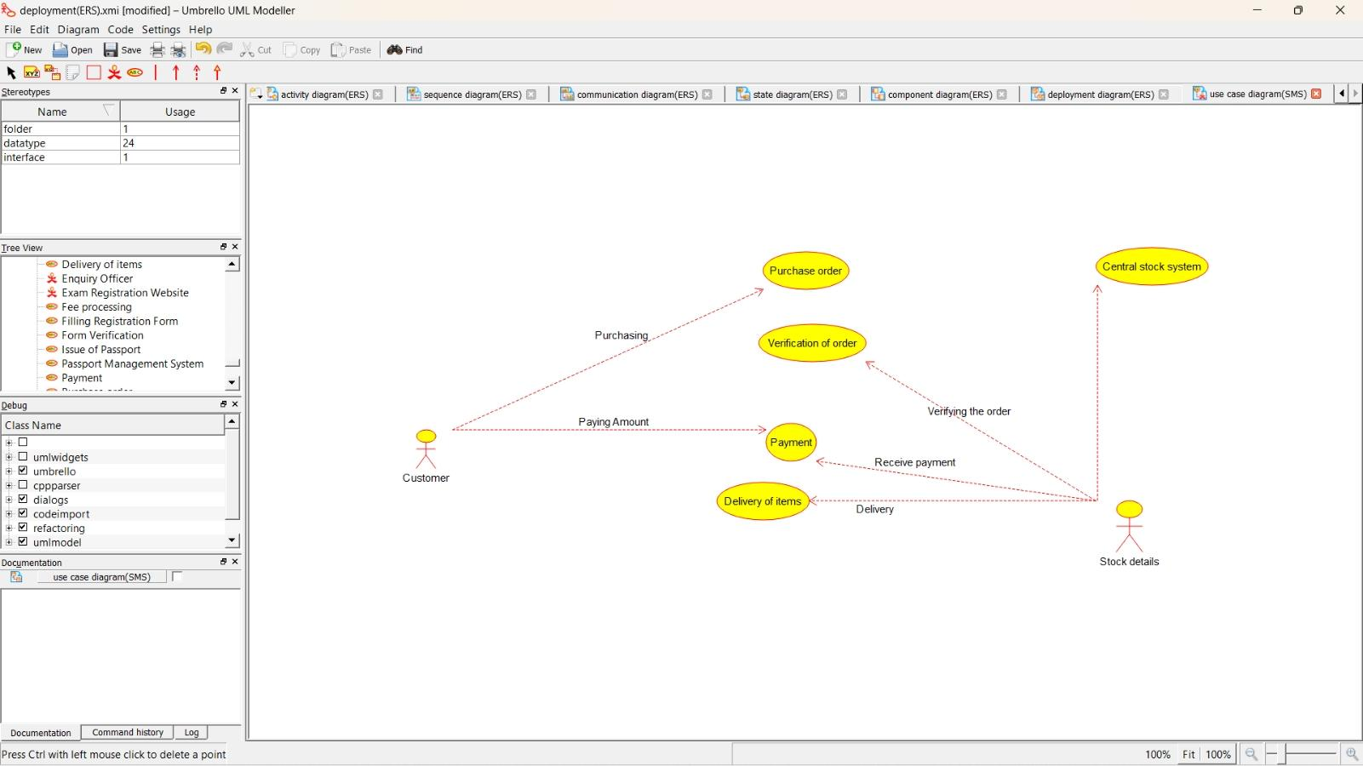

Class Diagram:

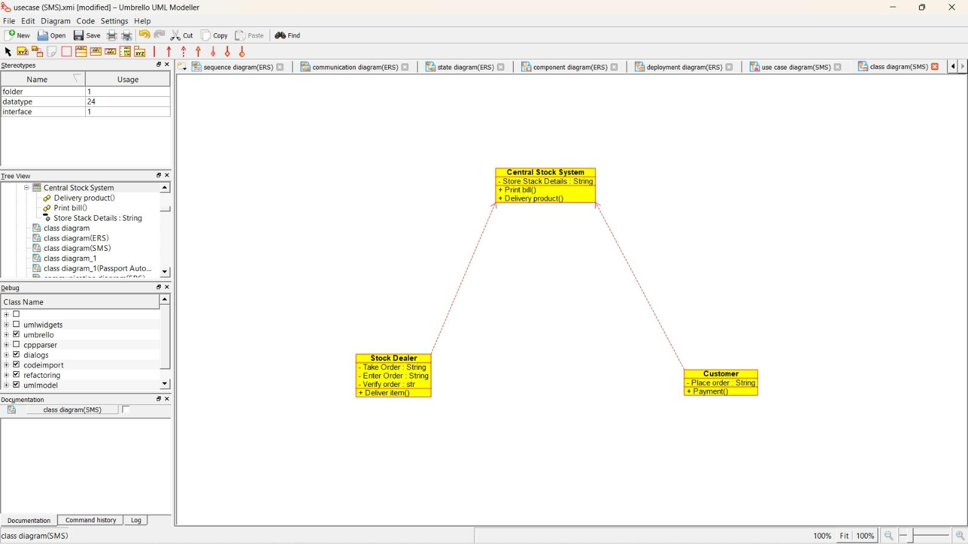Activity Diagram:

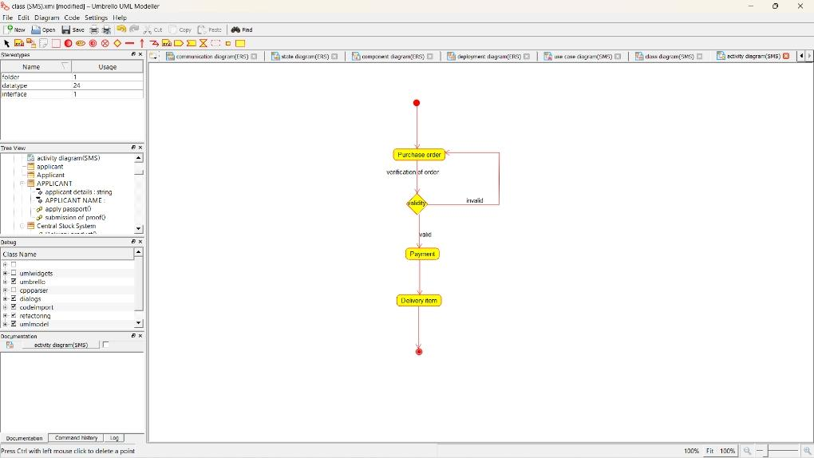

Sequence Diagram:

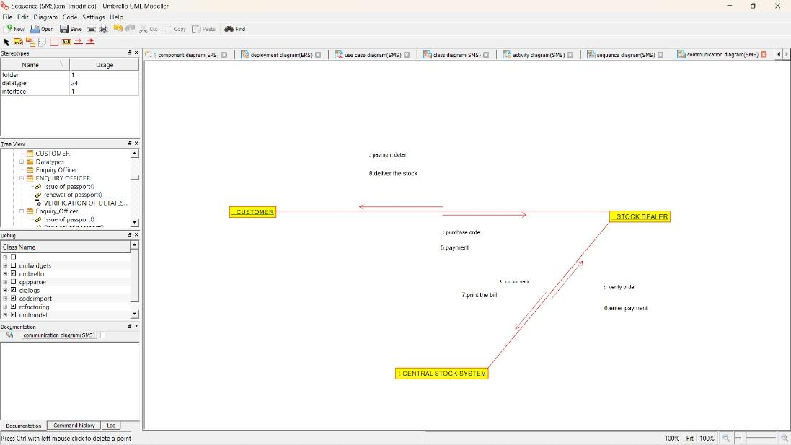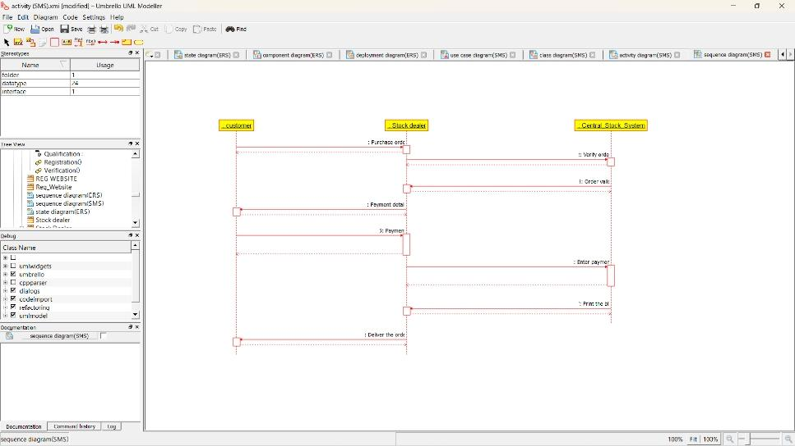Collaboration Diagram:

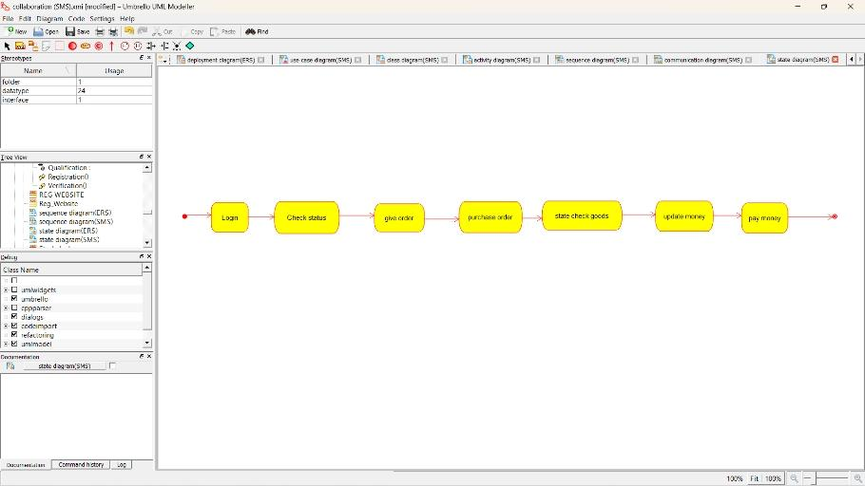State Diagram:

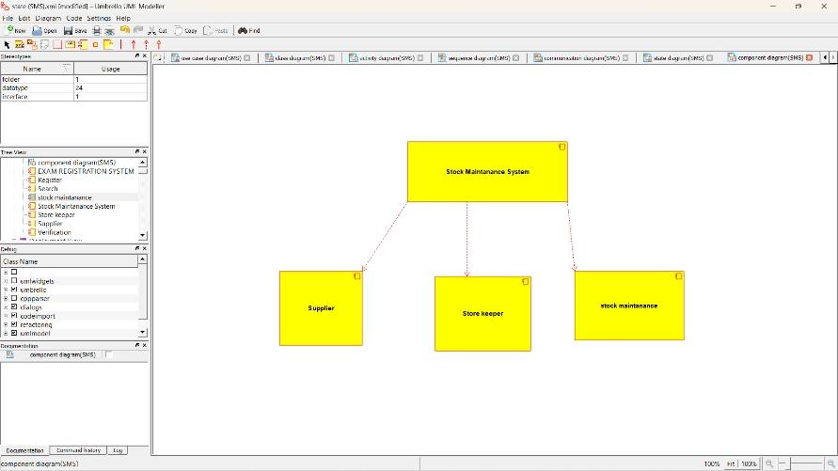Component Diagram:

Deployment Diagram:

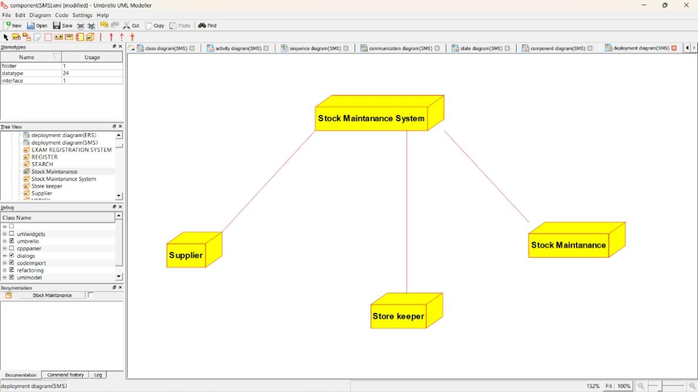PROGRAM CODING:

/**

* Class Central_Stock_System

*/

Public class Central_Stock_System {

//

// Fields

//

Private String Store_Stack_Details;

//

// Constructors

//

Public Central_Stock_System () { };

//

// Methods

//

//

// Accessor methods

//

/**

* Set the value of Store_Stack_Details
* @param newVar the new value of Store_Stack_Details

*/

Private void setStore_Stack_Details (String newVar) {

Store_Stack_Details = newVar;

}

/**

* Get the value of Store_Stack_Details
* @return the value of Store_Stack_Details

*/

Private String getStore_Stack_Details () {

Return Store_Stack_Details;

}

//

// Other methods

//

/**

*/

Public void Print_bill()

{

}

/**

*/

Public void Delivery_product()

{

}

}

/**

* Class Stock_Dealer

*/

Public class Stock_Dealer {

//

// Fields

//

Private String Take_Order;

Private String Enter_Order;

Private str Verify_order;

//

// Constructors

//

Public Stock_Dealer () { };

//

// Methods

//

//

// Accessor methods

//

/**

* Set the value of Take_Order
* @param newVar the new value of Take_Order

*/

Private void setTake_Order (String newVar) {

Take_Order = newVar;

}

/**

* Get the value of Take_Order
* @return the value of Take_Order

*/

Private String getTake_Order () {

Return Take_Order;

}

/**

* Set the value of Enter_Order
* @param newVar the new value of Enter_Order

*/

Private void setEnter_Order (String newVar) {

Enter_Order = newVar;

}

/**

* Get the value of Enter_Order
* @return the value of Enter_Order

*/

Private String getEnter_Order () {

Return Enter_Order;

}

/**

* Set the value of Verify_order
* @param newVar the new value of Verify_order

*/

Private void setVerify_order (str newVar) {

Verify_order = newVar;

}

/**

* Get the value of Verify_order
* @return the value of Verify_order

*/

Private str getVerify_order () {

Return Verify_order;

}

//

// Other methods

//

/**

*/

Public void Deliver_item()

{

}

}

/**

* Class Customer

*/

Public class Customer {

//

// Fields

//

Private String Place_order;

//

// Constructors

//

Public Customer () { };

//

// Methods

//

//

// Accessor methods

//

/**

* Set the value of Place_order
* @param newVar the new value of Place_order

*/

Private void setPlace_order (String newVar) {

Place_order = newVar;

}

/**

* Get the value of Place_order
* @return the value of Place_order

*/

Private String getPlace_order () {

Return Place_order;

}

//

// Other methods

//

/**

*/

Public void Payment()

{

}

}